DSA Lab

Mr. ALEEM AHMAD

Bahria University

**Lab # 10**

**Graph(BFS &DFS) Implementation**

LAB Journal

Asim Ali (01-131232-015)

**Lab 10: Graph (BFS &DFS) Implementation**

**TASK:**

BFS and DFS

**Lab Task GitHub Link:**

[Link](https://github.com/iasimkhan2005/DSA.git)

**OUTPUT:**

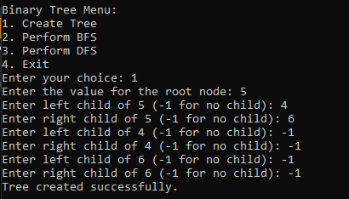

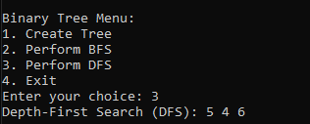

**CODE:**

#include <iostream>

#include <queue>

#include <stack>

using namespace std;

class Node {

public:

int data;

Node* left;

Node* right;

Node(int key) {

data = key;

left = right = nullptr;

}

};

// Breadth-First Search

void BFS(Node* root) {

if (root == nullptr) {

return;

}

queue<Node*> q;

q.push(root);

while (!q.empty()) {

Node* node = q.front();

q.pop();

cout << node->data << " ";

if (node->left != nullptr) {

q.push(node->left);

}

if (node->right != nullptr) {

q.push(node->right);

}

}

cout << endl;

}

// Depth-First Search

void DFS(Node* root) {

if (root == nullptr) {

return;

}

stack<Node*> s;

s.push(root);

while (!s.empty()) {

Node* node = s.top();

s.pop();

cout << node->data << " ";

// Push right child first so that left child is processed first

if (node->right != nullptr) {

s.push(node->right);

}

if (node->left != nullptr) {

s.push(node->left);

}

}

cout << endl;

}

Node* createTree() {

cout << "Enter the value for the root node: ";

int rootData;

cin >> rootData;

Node* root = new Node(rootData);

queue<Node*> q;

q.push(root);

while (!q.empty()) {

Node* current = q.front();

q.pop();

cout << "Enter left child of " << current->data << " (-1 for no child): ";

int leftData;

cin >> leftData;

if (leftData != -1) {

current->left = new Node(leftData);

q.push(current->left);

}

cout << "Enter right child of " << current->data << " (-1 for no child): ";

int rightData;

cin >> rightData;

if (rightData != -1) {

current->right = new Node(rightData);

q.push(current->right);

}

}

return root;

}

int main() {

Node* root = nullptr;

int choice;

do {

cout << "\nBinary Tree Menu:\n";

cout << "1. Create Tree\n";

cout << "2. Perform BFS\n";

cout << "3. Perform DFS\n";

cout << "4. Exit\n";

cout << "Enter your choice: ";

cin >> choice;

switch (choice) {

case 1: {

root = createTree();

cout << "Tree created successfully.\n";

break;

}

case 2:

if (root == nullptr) {

cout << "Tree is empty. Create the tree first.\n";

}

else {

cout << "Breadth-First Search (BFS): ";

BFS(root);

}

break;

case 3:

if (root == nullptr) {

cout << "Tree is empty. Create the tree first.\n";

}

else {

cout << "Depth-First Search (DFS): ";

DFS(root);

}

break;

case 4:

cout << "Exiting program.\n";

break;

default:

cout << "Invalid choice! Please try again.\n";

}

} while (choice != 4);

return 0;

}